Journal: Public Health Bulletin South Africa/SAMJ 3 000 words

Epidemiology of Pesticide Poisoning in South Africa: An Analysis of Poison Information Helpline calls, Notifiable Medical Conditions, and Butyrylcholinesterase tests in South Africa from 2020-2024.

Brian Brümmer*¹, Matimba Makhubele¹, Lehlohonolo Kumalo¹, Cindy Stephen², Jody Rusch^{6,7}, Leslie London⁴, Megan Prinsloo^{3,4,5}, Susan Nzenze¹, Natalie Mayet¹

*Corresponding Author

1. Division of Public Health Surveillance and Response, National Institute for Communicable Disease, a division of National Health Laboratory Service, Johannesburg, South Africa
2. Poisons Information Centre, Room 411 ICH Building, Red Cross War Memorial Children’s Hospital, Klipfontein Road, Rondebosch, Cape Town & Department of Paediatrics and Child Health, Faculty of Health Sciences, University of Cape, South Africa
3. Burden of Disease Research Unit, South African Medical Research Council;
4. School of Public Health and Family Medicine, Faculty of Health Sciences, University of Cape Town;
5. Institute for Lifecourse Development, University of Greenwich, London, UK
6. Division of Chemical Pathology, University of Cape Town, Cape Town, South Africa
7. National Health Laboratory Service, Groote Schuur Hospital, Cape Town, South Africa

Section | Words
Abstract | 261
Introduction | 539
Methodology | 579
Results (excl. tables and figures) | 443
Discussion (with recommendations) | 1182
Conclusion | 113
Total (excl. abstract) | 2856

Summary
(291 words)
Background: Highly hazardous pesticides (HHPs) gained media attention after being associated with deaths of six children in Soweto (October 2024). This paper aims to describe the epidemiology of pesticide poisonings in South Africa (2020–2024) using multiple routine data sources to identify public health actions for surveillance strengthening activities.
Objectives: To describe patterns of pesticide poisoning in South Africa (2020–2024) by triangulating routine surveillance, poison-centre and laboratory data, and to identify priority actions for surveillance strengthening and prevention.
Methods: We conducted a descriptive analysis of (i) Notifiable Medical Conditions (NMC) notifications of agricultural or stock-remedy poisoning, (ii) Poison Information Helpline (PIH) clinician calls, and (iii) National Health Laboratory Service butyrylcholinesterase (BChE) tests. Incidence was calculated using Statistics South Africa mid-year population estimates and standardised population weights. Temporal patterns and provincial heterogeneity were assessed; PIH call circumstances (accidental vs self-harm) were summarised.
Results: From 2020–2024, NMC recorded 3 457 notifications (~690/year). Notifications and PIH calls rose year-on-year with peaks in September–November. The highest Age-Standardised (ASR) rate per 100 000 person-years in BChE (0.46 95%CI 0.422-0.491) and NMC (0.19 95% Ci 0.171-0.216) cases was among females age 15-19 years. A significant burden also exists among children aged 0-1 (ASR for from NMC 0.18 95% CI 0.156-0.198). Among PIH calls, 99% of exposures in children <6 years were accidental, while 91% in adolescents (13–19 years) were reported intentional self-harm. Marked provincial differences were observed across data sources and in the proportion of severe BChE inhibition.
Conclusion: Pesticide poisonings are endemic in South Africa, with accidental exposures in young children and a pronounced burden of intentional self-harm among adolescent females. Priority actions include strengthened environmental health services, tighter control of pesticide availability, targeted mental-health interventions, and enhanced surveillance - particularly integrated, laboratory-linked NMC reporting and supplemented by strengthened mortality surveillance.

Introduction
(539 words)
South Africa (SA) has recently experienced increased media attention as a result of six children dying in Soweto in October 2024 in an incident that was linked to exposure to terbufos, an organophosphate insecticide. Terbufos is an organophosphate pesticide classified as Extremely hazardous (Class 1a) by the World Health Organisation (WHO). Under the National Health Act and its regulations, pesticide poisoning [or Agricultural or Stock-Remedy Poisoning (ASRP)], is now a Category 1 Notifiable Medical Condition (NMC), requiring immediate notification. The most highly toxic pesticides are the targets of a joint Food and Agricultural Organization World Health Organization (FAO/WHO) programme to eliminate highly hazardous pesticide (HHPs) as a strategy to reduce human harms and protect the environment(1).

Shortcomings in SA’s regulatory framework for pesticides have been previously noted(2). The principal; legislation for registering pesticides is more than 7 decades old (Farm Feeds, Agricultural remedies and Stock Remedies Act - Act No. 36 of 1947). The broader regulatory framework is extremely fragmented with limited opportunities for public participation and poor alignment with international best practice. In recognition of these shortcomings, a Policy Paper was issued by the Department of Agriculture in 2010(3) but little progress had been made in updating the legislative framework by the time the Soweto poisonings occurred.

One challenge for pesticide safety arises in resource-limited communities across South Africa where inadequate waste removal and sanitation services contribute to infestations of rats, cockroaches, and other vermin. In response, community members turn to using agricultural pesticides as bait to kill these urban pests. Informal markets provide easy access to a range registered or unregistered products, intended for agricultural use, known as "street pesticides," which include some HHPs like terbufos(4). Terbufos, has been widely sold in granular form by informal vendors and used by households for pest control. Terbufos is colloquially known as Halephirimi which translates from Sesotho to “you will never see the sunset” referring to the rapid lethality of this substance. Such “street pesticides” are highly toxic HHPs both unsuitable and illegal for domestic use(5).

In well-resourced countries, data on causes of death from the civil registration and vital statistics (CRVS) system are routinely used to inform policy and guide public health response. In South Africa, however, official statistics on causes of death in SA face numerous data quality challenges and an up to 4-year delay in data dissemination (6–9). The CRVS system was not designed for public health surveillance or for timeously responding to a public health crisis. Although toxicology data for deaths referred for forensic pathology investigation are available, they are completely de-identified for confidentiality purposes, and therefore cannot be easily used for epidemiological purposes in their current form as the data cannot be analysed by age or sex.

There is an urgent need to better understand the epidemiology of non-fatal pesticide poisonings and pesticide related deaths in South Africa, so as to recommend public health actions and surveillance improvements. In this paper, we describe the epidemiology of ASRP in the country by triangulating data from three routinely collected data sources available to the Ministerial Advisory Committee on Foodborne illnesses, established by the presidency of South Africa following the Soweto poisonings. Analysing multiple data sources may improve the quality of recommendations to enhance the NMC’s robustness in tracking poisoning epidemiology and surveillance of other public health conditions.

Methodology
(579 words)
Three data sources were used to assess the ongoing pesticide poisoning cases and its current burden in South Africa: (i) The Poison Information Helpline is a 24 hour national consultative service for the public and health care workers, run jointly by Poison Information Centres (PICs) at the Tygerberg Hospital and Red Cross War Memorial Hospital in Cape Town providing telephonic information on the identification and management of possible poisoning (PIH case). All call data are logged in the AfriTox TeleLog database curated by the national PIH; (ii) The Notifiable Medical Conditions platform is a data archive for all notifications including those related to pesticide poisoning (also as Agricultural and stock-remedy poisoning) in South Africa (notification) (iii) The National Health Laboratory Services (NHLS) records include all diagnostic tests requested in the public sector (BChE case). All data were extracted for the time-period 1 January 2020 to 31 December 2024.

Each source generated cases defined as follows:
A PIH case is one based on a call coming from a clinician who reports a patient being exposed to a herbicide, rodenticide or insecticide and who requires assistance in the diagnosis or management of the patient. Calls made by non-clinicians and repeat calls for the same patients were excluded.
A notification case is an of ASRP notifications that is based on a published case definition and notified to the NMC platform based on clinical suspicion from both health facilities and forensic pathology facilities(10). Notifications may come from any medical professional making a diagnosis, including Forensic Pathology Services.
A BChE case is derived from butyrylcholinesterase (BChE) enzyme activity test requests submitted to the National Health Laboratory Services (NHLS) from 2020-2024 (5 years). BChE is inhibited by organophosphates and carbamates making it a useful first line investigation in these pesticide poisoning cases. Data were deduplicated via the National Institute for Communicable Disease (NICD) surveillance data warehouse using fuzzy matching protocols; those included were unique tests. Tests showing severe enzyme inhibition classified as <10% of normal activity(11–13) were defined as a BChE case.

Data were analysed using R version 4.1.2. We reported Age-Standardised rates by computing age-specific rates standardised with WHO global population weights(14). We used the mid-year population estimates (MYPEs) for 2020-2024 published by Statistics South Africa (Stats SA) in 2025(15). To estimate the <1 year population, we used the number of registered live births for each year and subtracted the expected number of infant deaths computed as the product of that year’s births and infant mortality rate per 1000 live births (IMR) reported by Stats SA. The resulting number was subtracted from the 0-4 age category MYPE to generate the 1-4 year age category denominator for estimating rates. Similarly, the <1 age standardised weight was calculated as 1/5th of the 0-4 year age group weight, with the remaining 4/5th weight allocated to the 1-4 year age group. Age-specific rates were calculated by the sum of each year’s total population (as person-years) and dividing by the total number of cases in that age and sex stratum with Poisson confidence intervals(16). Age standardised rates were calculated by multiplying the age groups weight with the age-specific rate (and confidence interval) in each stratum.

For each data source, we implemented a cumulative sum control chart (CUSUM) on the daily notifications, Poison Centre calls, and BChE cases over a moving 180 day window. CUSUM signal detection used decision threshold (h) of 5 which indicating a cumulative deviation of five standard errors above the baseline mean required to flag a potential signal. CUSUM charts offer an advantage over monitoring standard deviation of case counts alone as it does not view days independently, accounting for gradual increases over a number of days. The CUSUM method has been successfully used to identify lead poisoning in another setting(17).

Ethics
Ethics approval for this review was provided from the Human Research Ethics Committee of the University of Witwatersrand (M201752) for a protocol that allows for reporting and the analysis of surveillance data. Access to Poisons Information Helpline of the Western Cape (PIHWC)
AfriTox™ TeleLog Database was granted by its director- the database is registered with University of Cape Town’s Faculty of Health Science Human Research Ethics Committee (R014/2014).

Results
(443 Words)
A total of 3 457 pesticide poisoning notifications were reported on the NMC surveillance system from 01 January 2020 to 31 December 2024 representing approximately 690 cases on average per annum. Overall, there is slight male predominance (53%). However, there is heterogeneity in the sex distribution by age categories. Using Age standardised Incidence rates (ASR) to compare age and sex, we demonstrated significant sex heterogeneity among age groups older than 9 years (Figure 1). The age-specific rate among cases age 0-1 ASRP notifications was notable (Females 9.95 and Males 10.32 cases per 100 000 person years) and there was no statistically significant difference between the sex of these rates.

A total of xx cases met the definition for a CHhE case over the same period. Unlike NMC cases, the ASR for BChE cases did not demonstrate that the 0-1 age group had the highest rates; instead, females aged 15-19 years had the highest ASR at 0.46 (95%CI 0.422-0.491) cases per 100 000 person years. Females had 2.19 (95%CI 1.91-2.51) higher ASR than male counterparts (p-value<0.001 [Supplementary table 1]). A similar trend of high rates in females aged 15-19, and males 30-34 was seen in ASRP notifications, although ASR across age groups was lower than BChE ASRs. (Figure 1).

A total of yy cases were clinician calls to the PIH over the same period, which was more than the number of NMC cases notifications during 2020 to 2024 but less than the number of BChE cases in the NHLS.

Temporal analysis indicates there has been a steady increase in year-on-year increase in “case” volume for all data sources over the period 2020 to 2024, with a a relatively low starting point noted for NMC notifications (Figure 2). Analysis of the CUSUM of NMC notifications indicates significant changes in notifications between of September to November each year.

Although the temporal trends across data sources are similar, there are different provincial patterns with lower volume of notifications of severe BChE cases in KZN compared to PIH calls (Figure 3). The most NMC notifications come from Gauteng (61%) and Free State (14%) districts, whereas PIH calls are predominantly from Gauteng (14%), KZN (34%) and WC (17%) districts (Figure 3). Cholinesterase testing reflecting severe inhibition comprised 14.6% of tests across all provinces but was much lower as a proportion in the Western Cape (<1%) and Northern Cape (0.2%) (Figure 4).

The circumstances of poisoning are collected by the PIH only and these data indicate that among the under 6-year age-group, 99% were reported as accidental, while 91% of poisonings among 13–19 year-olds were reported as intentional “self-harm” (Supplementary table 3). The majority of PIH calls indicated an unknown substance was ingested (28%), followed by Carbamates (15%), Pyrethroids (11%), and Organophosphates (10%) as the agents most commonly identified (Supplementary table 3).
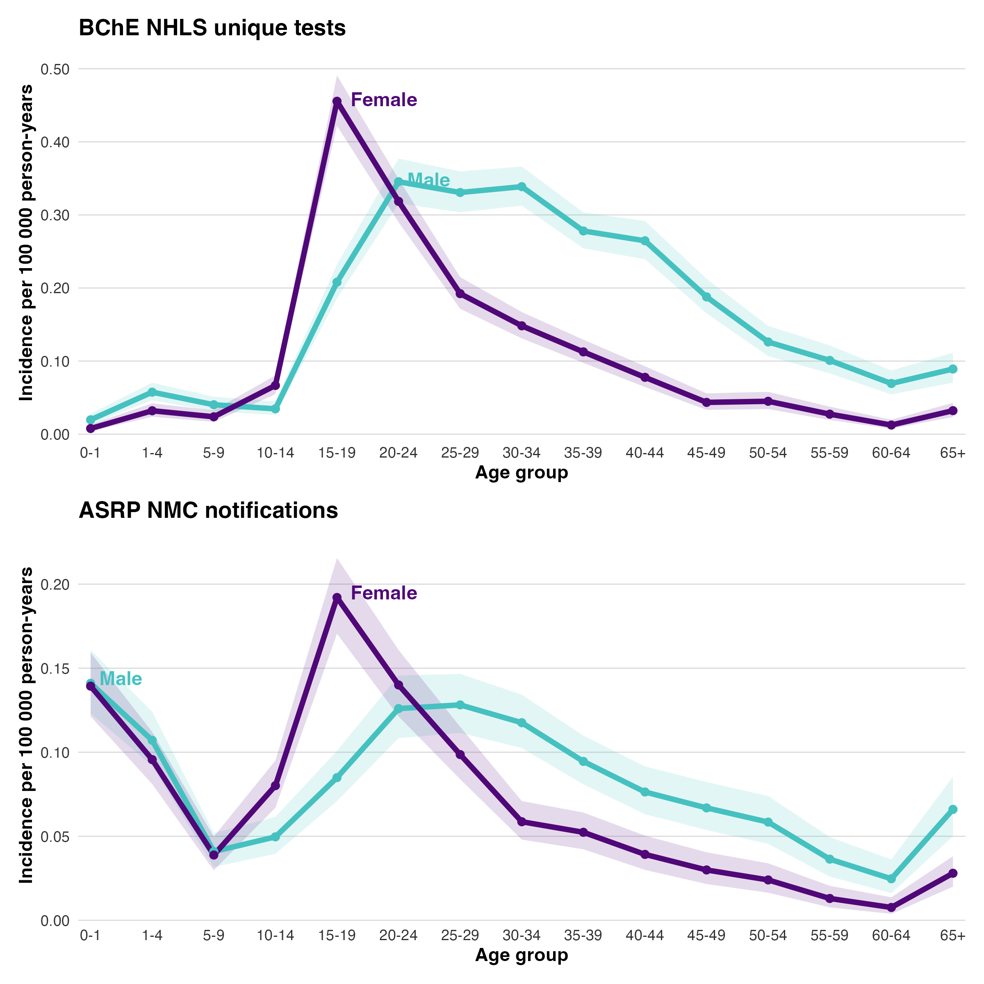
Severe Butyrylcholinesterase Inhibition (BChE) (<10% of normal) unique tests
Agricultural or stock remedy poisoning (ASRP) NMC notifications
Figure 1: Age standardised rate of BChE cases and Agricultural or Stock Remedy Poisoning (ASRP) NMC notifications per 100 000 Age person-years and by Age and Sex from 2020 to 2024, South Africa

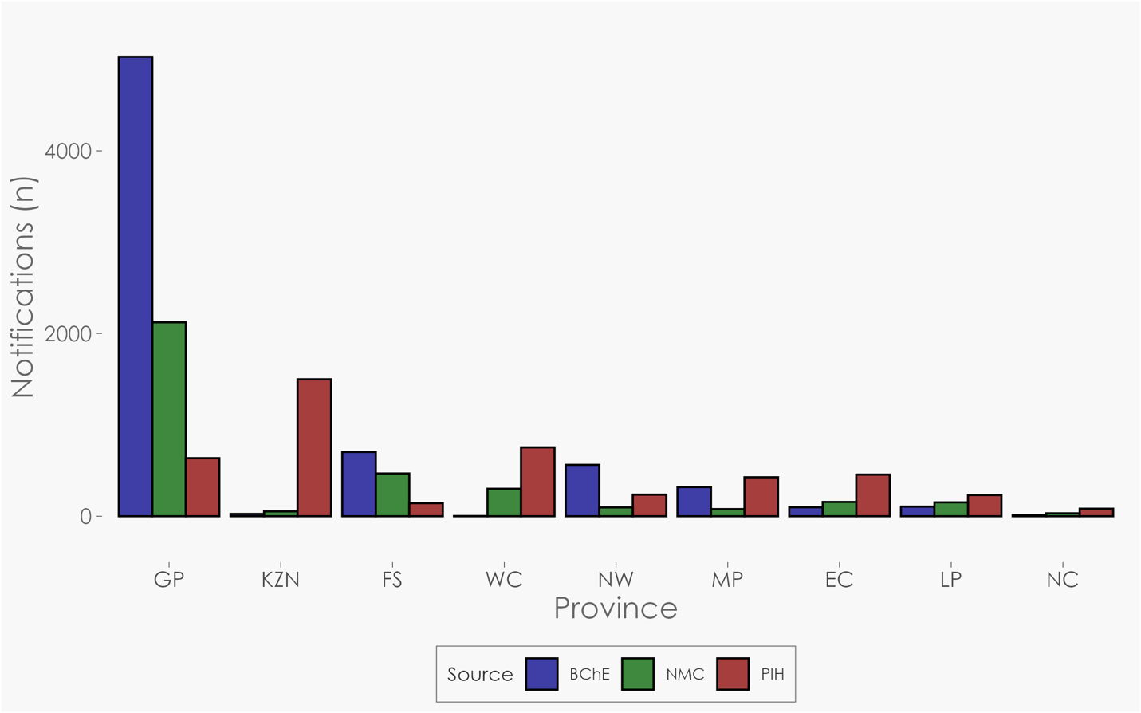
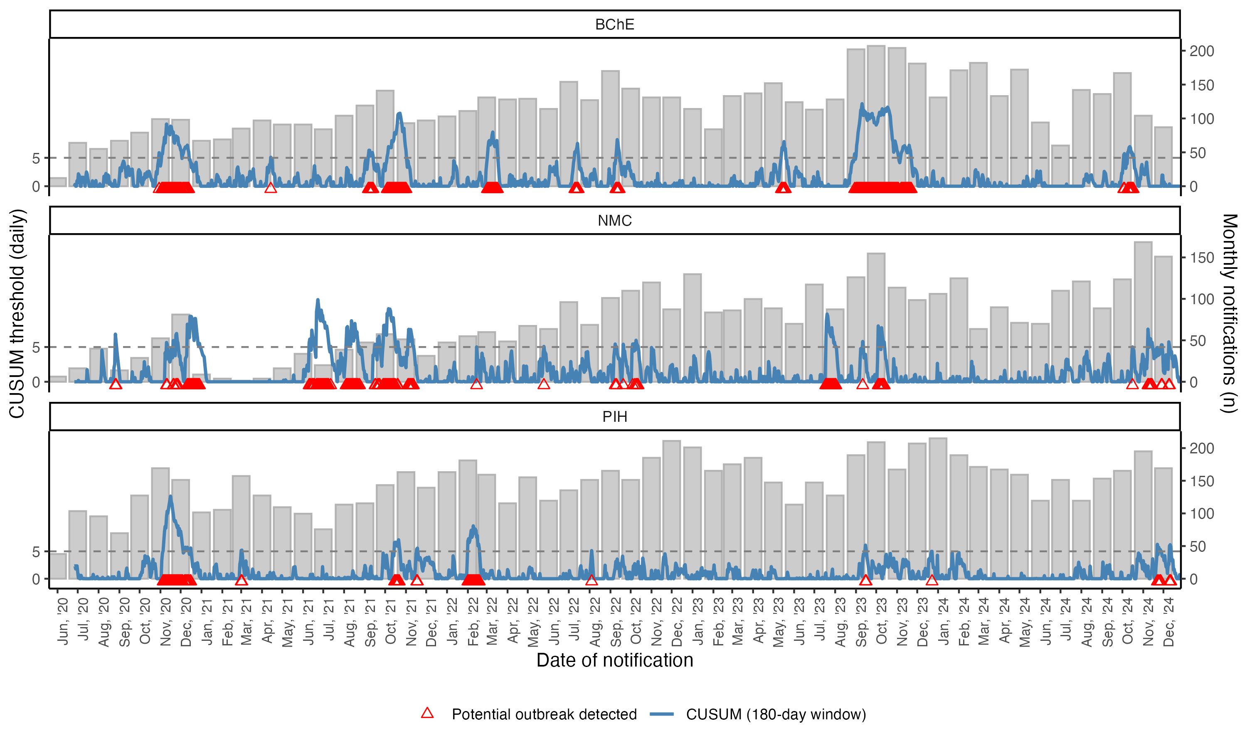
Figure 2: Case counts from each data source from 2020 to 2024, South Africa. Monthly Agricultural or stock remedy poisoning, severe BChE cases, and PIH calls are shown as grey bars. A 180-day Cumulative Sum (CUSUM) algorithm was applied to detect sustained increases in daily notifications above the expected baseline. The blue line represents the evolving CUSUM statistic (threshold). A “signal” denoted by the red triangle shape at y=0 is generated whenever the CUSUM value exceeds 5, indicating an increase in cases compared with the preceding 180-day baseline.
Figure 3: The total number of cases of poisonings collected by each data source from 2020 to 2024, South Africa. ChE represents severe cholinesterase inhibitions. NMC represents all notifications, and PIH represents all calls made by clinicians related to Herbicides, insecticides and rodenticides.
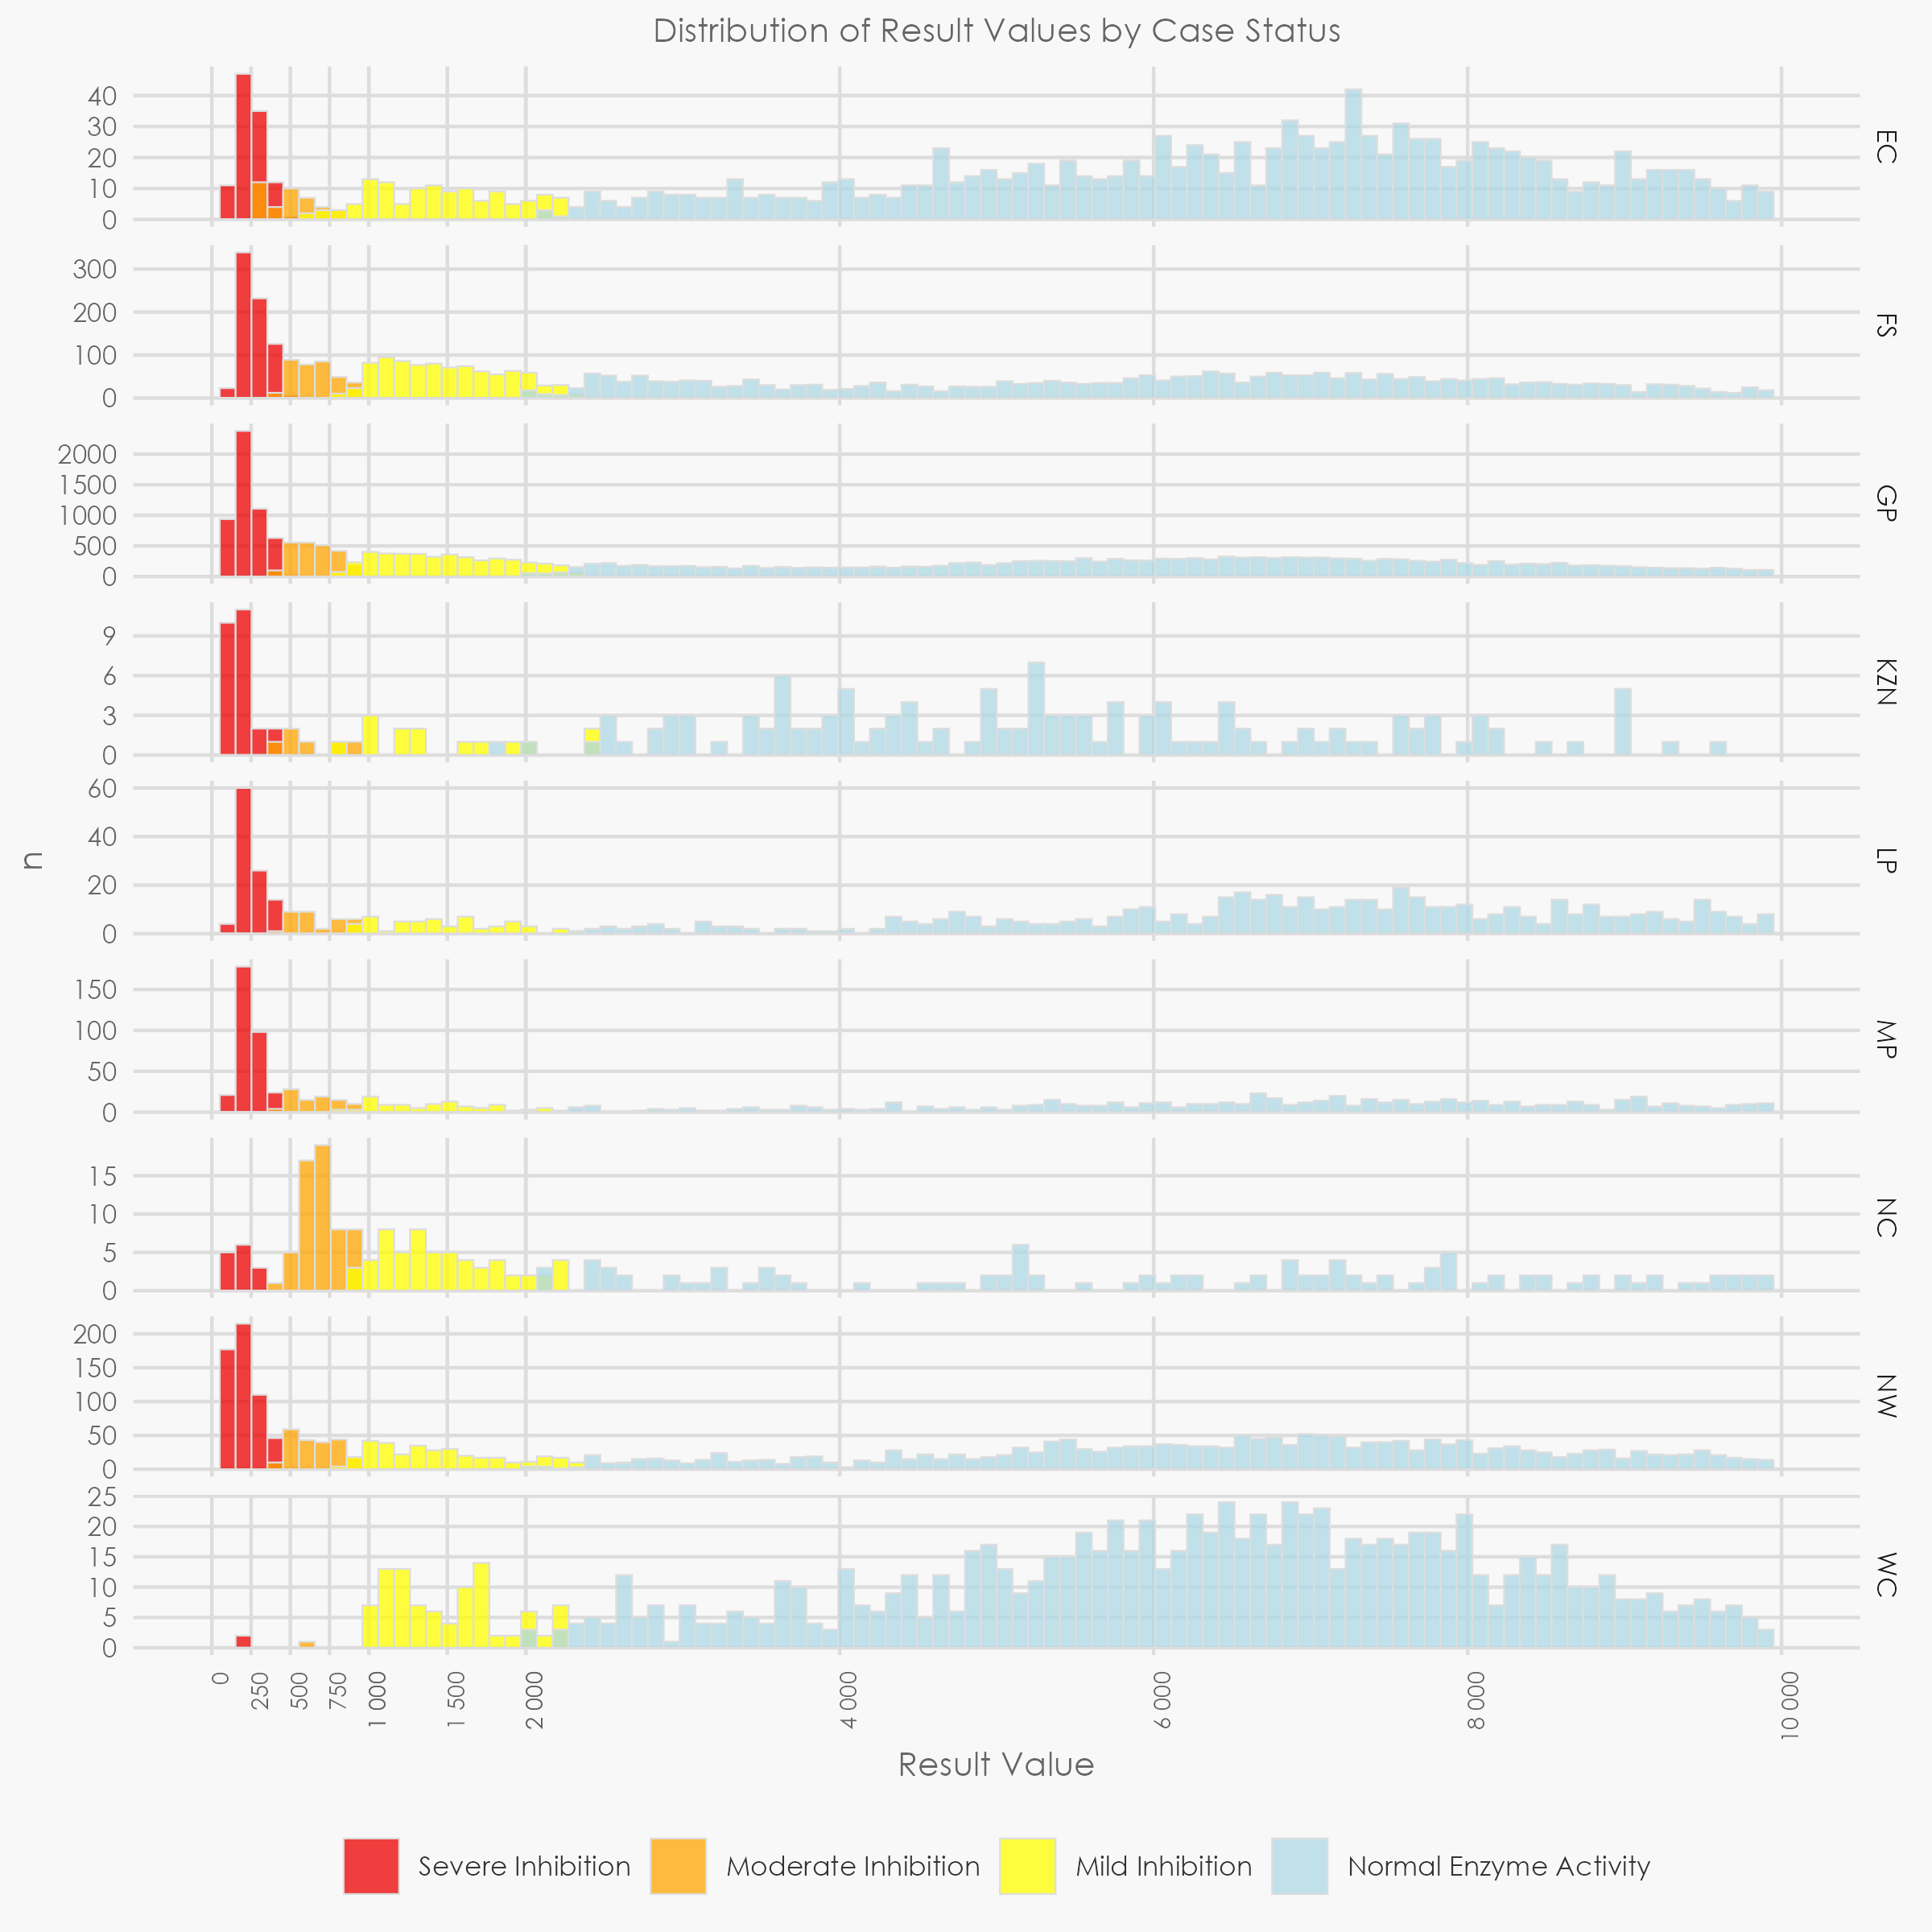
Figure 4: A histogram of the Butyrylcholinesterase (BChE) values among unique tests from NHLS data from 2020-2024 from the 9 provinces, South Africa

Discussion
(1135 words)
While NMC notifications demonstrate the occurrence of organophosphate poisoning in children under the age of one-year, these data simultaneously highlight a burden among teenage females (ages 10-14 and 15-19) and males aged 30-34. The CRVS system, NMC and NHLS platforms do not capture information on circumstance of poisoning, which would be critical to identify public health actions required to reduce morbidity and mortality related to pesticide poisoning.

However, it is plausible that young children (<5 years old) are exposed to pesticides unintentionally, potentially from the environment as they explore, parental clothing (fomites), or contaminated food(18). This epidemiological inference is supported by the PIH data showing that among the calls logged from clinicians, younger age groups are reported to have been exposed unintentionally. Previous research has suggested that atopic dermatitis amongst South African children is associated with household pesticide exposure(18). This highlights the need for safer environments for children nationally, so that HHPs are not used or needed to control vermin in peri-urban areas, or that less toxic but similarly effective alternatives are made available(19). Domestic exposure of children to pesticides is a long-standing public health challenge noted almost two decades ago. More recent findings of terbufos exposure responsible for child deaths undergoing autopsy at one Western Cape mortuary over the period 1 January 2010 to 31 December 2019(20) indicate the problem of child exposure to highly hazardous pesticides has not been addressed.

Pesticide poisoning among female teenagers, given their older age, are more likely intentional which is supported by PIH data which report that most calls in older age groups are related to intentional self-harm. A similar finding of females predominating the poisoning deaths in the 13-17 year age group was demonstrated in injury survey in SA(7). Between 1997 and 2016, suicide by poisoning was the leading method among females and second leading method in males(23). Since methods for suicide are driven by availability, familiarity, and ease-of-use(22) reducing the availability of the most toxic HHPs may reduce the number of deaths as a result of suicide attempts.

Sri Lanka placed restrictions on the import and sale of WHO class I toxic pesticides and halved the number suicide rates over an eight year period(24). The drop in suicide rates were sustained(12) and although other less toxic HHPs were also banned, the effect was still driven by banning the most toxic substances(25). Thus, banning the most toxic HHPs should be the prioritised public health action.

While the higher ASR in older male age groups (30+) compared to females are also concerning, men are known to use more lethal methods such as hanging and firearms for suicide(23) – restriction on these methods can be more challenging.

The COVID-19 pandemic likely affected NMC notifications during 2020 and 2021 whereas BChE and PIH did not exhibit a similar dip during 2020 and 2021. This may be due to excess workload on clinicians to manage and notify COVID-19 cases; although it may also reflect a reduction in occupational exposure. The PIH data does not suggest a high number of occupational exposures, given that occupational exposure is only opportunistically recorded. Nevertheless, accidental exposure is predominantly among those younger than the legal working age.

Temporal peaks in September–November recorded amongst PIH cases parallels resumption of agricultural spraying activities in some provinces and may partly reflect greater access in farming areas when pesticides are more available.

There is provincial heterogeneity identified when comparing the volume and proportion of cases by province across each data source. While each data source does not measure the exact same syndrome - explaining the different volume, it also suggests that provincial heterogeneity may be surveillance artefacts and may reflect, inter alia, the varying strength of NMC surveillance in different provinces, the awareness of the PIH as a resource, the possible confusion that PIH calls constitute a notification and subsequent failure to notify, and potential differences in availability of BChE testing in different provinces. KZN specifically shows a ‘preference’ for calling the PIH hotline over NMC notification and BChE testing.

Aside from surveillance artefacts, the differing BChE enzyme activity across provinces suggests some difference at a biological and clinical level, heterogeneity may reflect different chemical agents and presentations of acute poisoning in different provinces. The low proportion of severe BChE tests in WC and NC suggest either different chemical agents or different routes of exposure(26) compared to other provinces where poisoning events are severe enough to present to hospital but may not suppress BChE as severely as the potentially prevalent agents in other provinces.

Currently, identifying the specific chemical agent involved in an acute poisoning of a living patient is not available in the public sector (which serves >80% of the population) as clinical care can be guided on signs and symptoms without knowledge of the specific agent. However, the lack of data on the specific agent involved limits targeted public health action at the policy level - where identifying agents assist to identify pesticides requiring stricter regulation or banning - to the local level where EHPs may investigate the presence of the specific agent in the environment.

Recommendations
We recommend the following public health actions: (i) improving community level environmental health services, particularly sanitation and waste removal, to reduce the demand for domestic use of pesticides, particularly HHPs and removal of pesticides from informal markets sold for domestic pest control; (ii) tightly regulate the availability of HHPs and/or, where necessary, implement bans on sale or usage of these agents; (iii), and address the root causes of suicide, particularly in teenage females, which may or may not be related to gender-based violence, through the provision of accessible mental health services, among other strategies.

We propose the following surveillance strengthening efforts: Strengthen pesticide-poisoning surveillance by enhancing the NMC form (including pesticide type [Supplementary table 4], include intent or manner of poisoning, EHP follow-up investigation information and automatic lab alerts for severe BChE cases to NMC). Data quality in PIH Telelog can be improved by improving age group granularity, and separately piloting a chemical-agent identification in high-burden districts. Although not a focus of this paper, improvement in mortality surveillance that accurately and in near real-time identify the underlying cause of death to inform public health action should be prioritised(6) along with in-country experts and stakeholders in the CRVS system.

NMC data use for public health
The NMC data on the endemicity of poisonings in SA was used to inform the MAC advisoryon Terubufos. Weekly reports were provided to the National Joint operations and Intelligence Structure (NATJOINTS) to monitor poisoning events. The resulting assembly of relevant data presented to government stakeholders and cabinet, contributed to the cabinet decision that terbufos would be officially banned in South Africa. At the time of writing, official regulation has yet to be gazetted. The NMC was able to provide near-real time data to inform public health actions, however, data quality and representativeness remain areas for strengthening. To further improve surveillance for action, there is a pilot of an electronic Medical Certification of Cause of Death (eMCCD) system currently being rolled out in SA by the National Department of Health.

Conclusion
(113 words)
Pesticide poisoning is endemic in South Africa, notwithstanding recent media attention and strong government responses. Teenage females (15–19 years) are disproportionately affected compared to males-likely reflecting self-harm practices. In addition, infants (<1 year) have a high rate of notification among both sexes. Our findings suggest the urgent need for real-time, laboratory-linked notification that collects information on the circumstances, chemical agent and environmental investigation. Improved notifications of cases, integrated across all databases, should be supplemented by accurate identification of the underlying-cause-of-death in near real-time in mortality surveillance systems. Improved surveillance systems will enable rapid detection of emerging poisoning clusters and support targeted prevention. Prioritizing these actions can turn political will into measurable reductions in poisoning-related morbidity and mortality.

Acknowledgments
We acknowledge the Division of Public Health, Surveillance, and Response, NICD/National Health Laboratory Service, for their oversight of the NMCss, from which we extracted the reported data. This acknowledgment extends to individuals such as Ms. Mabore Morifi, the NICD Information Technology team (Mr. Gloseije Bazolana, Mr. Jimmy Khoza and Dr Trevor Bell), provincial NMC nurses and coordinators, the NHLS chemical laboratory, the Ministerial Advisory Committee on Foodborne Illnesses and the Poison Information Helpline, and all healthcare workers who contribute by notifying, investigating and treating people with acute poisoning.

Conflict of Interest
There is no conflict of interest for all authors.

Author Contributions
BB, writing and analysis
LK, inception, writing
MM, inception, writing
CS, inception, writing
LL, commented on writing
JR, commented on writing
MP, commented on writing and analysis

Funding sources
No external funding was received for this study. Institutional resources were used.

References
1. FAO and WHO. Detoxifying agriculture and health from highly hazardous pesticides - A call for action [Internet]. FAO and WHO; 2019. Available from: https://www.who.int/publications/i/item/9789241517065
2. London L. Challenges for improving surveillance for pesticide poisoning: policy implications for developing countries. Int J Epidemiol. 2001 June 1;30(3):564–70.
3. ADOPTION OF PESTICIDE MANAGEMENT POLICY FOR SOUTH AFRICA [Internet]. Government Gazzette; 2010 [cited 2025 Sept 23]. Available from: https://www.gov.za/sites/default/files/gcis_document/201409/338991120.pdf
4. Rother HA. Pesticide vendors in the informal sector: Trading health for income. NEW Solut J Environ Occup Health Policy. 2016;26(2):241–52.
5. Godsmark CN, Rother HA. Part of the solution–an engaged scholarship approach for the sustainable reduction of street pesticides and poisonings. Glob Public Health. 2019;14(10):1535–45.
6. Prinsloo M, Bradshaw D, Joubert J, Matzopoulos R, Groenewald P. South Africa’s vital statistics are currently not suitable for monitoring progress towards injury and violence Sustainable Development Goals. S Afr Med J. 2017 May;107(6):470.
7. Prinsloo M, Roomaney RA, Neethling I, Basera NW, Groenewald P, Matzopoulos R, et al. Tracking poison ingestion deaths for South Africa: The need for access to timely reliable data. S Afr Med J. 2025 June 3;115(5):e2993.
8. Groenewald P, Azevedo V, Daniels J, Evans J, Boulle A, Naledi T, et al. The importance of identified cause-of-death information being available for public health surveillance, actions and research. S Afr Med J. 2015 Sept 21;105(7):528.
9. Bradshaw D, Dorrington RE, Laubscher R, Moultrie TA, Groenewald P. Tracking mortality in near to real time provides essential information about the impact of the COVID-19 pandemic in South Africa in 2020. S Afr Med J. 2021 May 21;111(8):732.
10. NMC Category 1 case definitions [Internet]. National Institute for Communicable disease, A divisision of the National Health Laboratory Services; 2024 [cited 2024 Dec 18]. Available from: https://www.nicd.ac.za/nmc-overview/nmc-resources/
11. Chaudhary S, Jain N, Atam V, Agarwal A, Singh K, Sawlani K, et al. Prognostic significance of estimation of pseudocholinesterase activity and role of pralidoxime therapy in organophosphorous poisoning. Toxicol Int. 2013;20(3):214.
12. Buckley NA, Fahim M, Raubenheimer J, Gawarammana IB, Eddleston M, Roberts MS, et al. Case fatality of agricultural pesticides after self-poisoning in Sri Lanka: a prospective cohort study. Lancet Glob Health. 2021 June;9(6):e854–62.
13. Rao K, Rangappa P, Jacob I, Hiremath P. Pseudocholinesterase as a predictor of mortality and morbidity in organophosphorus poisoning. Indian J Crit Care Med. 2016 Oct;20(10):601–4.
14. Ahmad OB, Boschi-Pinto C, Lopez AD, Murray CJ, Lozano R, Inoue M. Age Standardization of Rates: A new WHO Standard.
15. Mid-Year population Estimates [Internet]. Statistics South Africa; 2025. Available from: https://www.statssa.gov.za/publications/P0302/P03022025.pdf
16. Daly L. Simple SAS macros for the calculation of exact binomial and Poisson confidence limits. Comput Biol Med. 1992;22(5):351–61.
17. Dignam T, Hodge J, Chuke S, Mercado C, Ettinger AS, Flanders WD. Use of the CUSUM and Shewhart control chart methods to identify changes of public health significance using childhood blood lead surveillance data. Environ Epidemiol. 2020 Apr;4(2):e090.
18. Tolosana S, Rother HA, London L. Child’s play: Exposure to household pesticide use among children in rural, urban and informal areas of South Africa. 2009;99(3).
19. Swartz A, Levine S, Rother HA, Langerman F. Toxic layering through three disciplinary lenses: childhood poisoning and street pesticide use in Cape Town, South Africa. Med Humanit. 2018;44(4):247–52.
20. Davies B, Hlela MBKM, Rother HA. Child and adolescent mortality associated with pesticide toxicity in Cape Town, South Africa, 2010–2019: a retrospective case review. BMC Public Health. 2023 Apr 28;23(1):792.
21. Department of Emergency Medicine, Faculty of Health Sciences, University of the Witwatersrand, Johannesburg, South Africa, Laher AE, Motara F, Department of Emergency Medicine, Faculty of Health Sciences, University of the Witwatersrand, Johannesburg, South Africa, Gihwala R, Department of Emergency Medicine, Faculty of Health Sciences, University of the Witwatersrand, Johannesburg, South Africa, et al. The profile of patients presenting with intentional self-poisoning to the Charlotte Maxeke Johannesburg Academic Hospital emergency department, South Africa. S Afr Med J. 2022 May 1;112(5):347–51.
22. Onoya ED, Makwakwa NL, Motloba DP. Temporal variation in suicide in peri-urban Pretoria. South Afr Fam Pract [Internet]. 2021 May 11 [cited 2025 Jan 6];63(1). Available from: https://safpj.co.za/index.php/safpj/article/view/5260
23. Kootbodien T, Naicker N, Wilson KS, Ramesar R, London L. Trends in Suicide Mortality in South Africa, 1997 to 2016. Int J Environ Res Public Health. 2020 Mar 12;17(6):1850.
24. Gunnell D, Fernando R, Hewagama M, Priyangika WDD, Konradsen F, Eddleston M. The impact of pesticide regulations on suicide in Sri Lanka. Int J Epidemiol. 2007 Dec 1;36(6):1235–42.
25. Noghrehchi F, Dawson AH, Raubenheimer J, Mohamed F, Gawarammana IB, Eddleston M, et al. Restrictions on Pesticides and Deliberate Self-Poisoning in Sri Lanka. JAMA Netw Open. 2024 Aug 6;7(8):e2426209.
26. Robb EL, Regina AC, Baker MB. Organophosphate Toxicity. In: StatPearls [Internet]. Treasure Island (FL): StatPearls Publishing; 2024 [cited 2025 Jan 6]. Available from: http://www.ncbi.nlm.nih.gov/books/NBK470430/

Supplementary tables:
Supplementary table 1: Supplementary table of age standardised rates by age and sex for BChE NHLS unique tests between 2020 to 2024, in South Africa
 |  | Female* |  |  |  |  | Male*
 |  | Average*  Population | Average  cases | Age Specific Rate | Age  Standardised  Rate† | 95% CI | Average*  Population | Average  cases | Age Specific Rate | Age Standardised Rate† | 95% CI | p-value‡
<1 | 1.77 | 546,939 | 2.4 | 0.44 | 0.01 | 0.004-0.014 | 557,877 | 6.2 | 1.11 | 0.02 | 0.013-0.028 | 0.005
1-4 | 7.09 | 2,253,437 | 12.2 | 0.54 | 0.04 | 0.029-0.049 | 2,316,412 | 22.4 | 0.97 | 0.07 | 0.056-0.082 | <0.001‡
5-9 | 8.69 | 2,774,367 | 7.0 | 0.25 | 0.02 | 0.015-0.030 | 2,846,451 | 10.6 | 0.37 | 0.03 | 0.024-0.042 | 0.088
10-14 | 8.60 | 2,811,923 | 21.8 | 0.78 | 0.07 | 0.055-0.080 | 2,875,127 | 11.6 | 0.40 | 0.03 | 0.026-0.045 | <0.001
15-19 | 8.47 | 2,540,033 | 136.6 | 5.38 | 0.46 | 0.422-0.491 | 2,573,677 | 63.2 | 2.46 | 0.21 | 0.186-0.232 | <0.001
20-24 | 8.22 | 2,348,302 | 91.0 | 3.88 | 0.32 | 0.290-0.349 | 2,375,059 | 99.8 | 4.20 | 0.35 | 0.316-0.377 | 0.2
25-29 | 7.93 | 2,573,460 | 62.4 | 2.42 | 0.19 | 0.172-0.215 | 2,623,535 | 109.4 | 4.17 | 0.33 | 0.304-0.360 | <0.001
30-34 | 7.61 | 2,750,884 | 53.6 | 1.95 | 0.15 | 0.131-0.167 | 2,822,264 | 125.6 | 4.45 | 0.34 | 0.313-0.366 | <0.001
35-39 | 7.15 | 2,539,900 | 40.0 | 1.57 | 0.11 | 0.098-0.129 | 2,571,477 | 100.0 | 3.89 | 0.28 | 0.254-0.304 | <0.001
40-44 | 6.59 | 2,050,188 | 24.2 | 1.18 | 0.08 | 0.065-0.093 | 2,002,275 | 80.4 | 4.02 | 0.26 | 0.239-0.292 | <0.001
45-49 | 6.04 | 1,693,946 | 12.2 | 0.72 | 0.04 | 0.033-0.056 | 1,607,566 | 50.0 | 3.11 | 0.19 | 0.165-0.213 | <0.001
50-54 | 5.37 | 1,431,048 | 12.0 | 0.84 | 0.05 | 0.034-0.058 | 1,268,174 | 29.8 | 2.35 | 0.13 | 0.107-0.148 | <0.001
55-59 | 4.55 | 1,261,311 | 7.6 | 0.60 | 0.03 | 0.019-0.038 | 1,000,475 | 22.2 | 2.22 | 0.10 | 0.083-0.122 | <0.001
60-64 | 3.72 | 1,070,153 | 3.6 | 0.34 | 0.01 | 0.007-0.020 | 783,006 | 14.6 | 1.86 | 0.07 | 0.054-0.087 | <0.001
65+ | 8.23 | 2,351,912 | 9.2 | 0.39 | 0.03 | 0.024-0.043 | 1,421,514 | 15.4 | 1.08 | 0.09 | 0.070-0.111 | <0.001
Total | 100.00 | 30,997,802 | 494.4 | 1.59 | 1.59 | 1.533-1.659 | 29,644,888 | 760.2 | 2.56 | 2.56 | 2.483-2.647 | <0.001
*Population estimates are taken from Statistics SA, info on the 0-1 year age group can be found in the methodology. Average populations and average cases from the 5 year period (2020-2024) are presented for South Africa. Age-specific Rates and Age Standardised Rates are rates per 100 000 person years.
†Age Standardised Rates (ASR) are calculated by multiplying the weight (as a proportion) from the WHO world standard population for each age category by the age-specific rate for that age category.
‡Two-sample Poisson exact test comparing female vs male incidence within each age group (two-sided).

Supplementary table 2: Supplementary table of age standardised rates by age and sex for ASRP NMC notifications between 2020 to 2024, in South Africa
 |  | Female* |  |  |  |  | Male*
 |  | Average  Population | Average  cases | Age Specific Rate | Age  Standardised  Rate† | 95% CI | Average  Population | Average  cases | Age Specific Rate | Age  Standardised  Rate† | 95% CI | p-value
<1 | 1.77 | 546,939 | 43.0 | 7.86 | 0.14 | 0.121-0.159 | 557,877 | 44.4 | 7.96 | 0.14 | 0.123-0.161 | >0.9
1-4 | 7.09 | 2,253,437 | 30.4 | 1.35 | 0.10 | 0.081-0.112 | 2,316,412 | 35.0 | 1.51 | 0.11 | 0.092-0.124 | 0.3‡
5-9 | 8.69 | 2,774,367 | 7.0 | 0.25 | 0.02 | 0.015-0.030 | 2,846,451 | 10.6 | 0.37 | 0.03 | 0.024-0.042 | 0.088
10-14 | 8.60 | 2,811,923 | 39.0 | 1.39 | 0.12 | 0.103-0.137 | 2,875,127 | 19.2 | 0.67 | 0.06 | 0.047-0.070 | <0.001
15-19 | 8.47 | 2,540,033 | 142.6 | 5.61 | 0.48 | 0.441-0.512 | 2,573,677 | 72.6 | 2.82 | 0.24 | 0.215-0.265 | <0.001
20-24 | 8.22 | 2,348,302 | 77.8 | 3.31 | 0.27 | 0.246-0.301 | 2,375,059 | 101.8 | 4.29 | 0.35 | 0.322-0.384 | <0.001
25-29 | 7.93 | 2,573,460 | 62.0 | 2.41 | 0.19 | 0.170-0.214 | 2,623,535 | 112.0 | 4.27 | 0.34 | 0.311-0.368 | <0.001
30-34 | 7.61 | 2,750,884 | 49.2 | 1.79 | 0.14 | 0.120-0.154 | 2,822,264 | 122.8 | 4.35 | 0.33 | 0.305-0.358 | <0.001
35-39 | 7.15 | 2,539,900 | 38.2 | 1.50 | 0.11 | 0.093-0.124 | 2,571,477 | 95.6 | 3.72 | 0.27 | 0.243-0.291 | <0.001
40-44 | 6.59 | 2,050,188 | 21.6 | 1.05 | 0.07 | 0.057-0.084 | 2,002,275 | 79.2 | 3.96 | 0.26 | 0.236-0.288 | <0.001
45-49 | 6.04 | 1,693,946 | 13.0 | 0.77 | 0.05 | 0.036-0.059 | 1,607,566 | 42.0 | 2.61 | 0.16 | 0.137-0.181 | <0.001
50-54 | 5.37 | 1,431,048 | 12.2 | 0.85 | 0.05 | 0.035-0.059 | 1,268,174 | 28.2 | 2.22 | 0.12 | 0.101-0.141 | <0.001
55-59 | 4.55 | 1,261,311 | 4.6 | 0.36 | 0.02 | 0.011-0.025 | 1,000,475 | 21.2 | 2.12 | 0.10 | 0.079-0.117 | <0.001
60-64 | 3.72 | 1,070,153 | 4.4 | 0.41 | 0.02 | 0.010-0.023 | 783,006 | 12.8 | 1.63 | 0.06 | 0.047-0.078 | <0.001
65+ | 8.23 | 2,351,912 | 8.2 | 0.35 | 0.03 | 0.021-0.039 | 1,421,514 | 13.6 | 0.96 | 0.08 | 0.061-0.100 | <0.001
Total | 100.00 | 30,997,802 | 494.4 | 1.59 | 1.59 | 1.533-1.659 | 29,644,888 | 760.2 | 2.56 | 2.56 | 2.483-2.647 | <0.001
*Population estimates are taken from Statistics SA, info on the 0-1 year age group can be found in the methodology. Average populations and average cases from the 5 year period (2020-2024) are presented for South Africa. Age-specific Rates and Age Standardised Rates are rates per 100 000 person years.
†Age Standardised Rates (ASR) are calculated by multiplying the weight (as a proportion) from the WHO world standard population for each age category by the age-specific rate for that age category.
‡Two-sample Poisson exact test comparing female vs male incidence within each age group (two-sided).

Supplementary table 3: Supplementary table describing the calls analysed to the PIH by whether or not they were Accidental or Self-harm.
 | Overall  N = 4,700 | Self-harm  N = 2,818 | Unintentional poisoning  N = 1,882 | p-value¹
Patient age, n (%) |  |  |  | <0.001
<5 yrs | 696 (100) | 7 (1.0) | 689 (99)
5-12 yrs | 179 (100) | 50 (28) | 129 (72)
13-19 yrs | 666 (100) | 600 (90) | 66 (9.9)
20-59 yrs | 2,707 (100) | 2,022 (75) | 685 (25)
≥60 yrs | 187 (100) | 75 (40) | 112 (60)
Unknown | 265 | 64 | 201
Substance use category, n (%) |  |  |  | 0.039
Agri (Herb, Fungicide, Other) | 727 (100) | 461 (63) | 266 (37)
Insecticides & Rodenticides | 3,973 (100) | 2,357 (59) | 1,616 (41)
Substance Category
Reported Unknown, n (%) | 1,195 (30) | 788 (32) | 407 (27) | <0.001
Carbamates, n (%) | 558 (14) | 367 (15) | 191 (13) | 0.030
Pyrethroids, n (%) | 441 (11) | 161 (6.6) | 280 (18) | <0.001
Organophosphates, n (%) | 334 (8.4) | 226 (9.2) | 108 (7.1) | 0.018
Formamidine Insecticides, n (%) | 315 (7.9) | 201 (8.2) | 114 (7.5) | 0.41
Anticoagulant Rodenticides, n (%) | 314 (7.9) | 239 (9.8) | 75 (4.9) | <0.001
Herbicides, n (%) | 301 (7.6) | 208 (8.5) | 93 (6.1) | 0.006
Other Toxicants, n (%) | 154 (3.9) | 27 (1.1) | 127 (8.3) | <0.001
Paraquat, n (%) | 111 (2.8) | 72 (2.9) | 39 (2.6) | 0.48
Phosphides/Phosphine/Phosphates, n (%) | 102 (2.6) | 76 (3.1) | 26 (1.7) | 0.007
Phenylpyrazoles, n (%) | 92 (2.3) | 64 (2.6) | 28 (1.8) | 0.11
Fungicides & Inorganics, n (%) | 27 (0.7) | 6 (0.2) | 21 (1.4) | <0.001
Neonicotinoids, n (%) | 25 (0.6) | 11 (0.4) | 14 (0.9) | 0.069
¹Pearson's Chi-squared test
 |  |  | Overall  N = 4,700 | Self-harm  N = 2,818 | Unintentional poisoning  N = 1,882 | p-value¹
Patient age, n (%) |  |  |  |  |  | <0.001
<5 yrs |  |  | 696 (100) | 7 (1.0) | 689 (99)
6-12 yrs |  |  | 179 (100) | 50 (28) | 129 (72)
13-19 yrs |  |  | 666 (100) | 600 (90) | 66 (9.9)
20-59 yrs |  |  | 2,707 (100) | 2,022 (75) | 685 (25)
≥60 yrs |  |  | 187 (100) | 75 (40) | 112 (60)
Unknown |  |  | 265 | 64 | 201
Substance use category, n (%) |  |  |  |  |  | 0.039
Agri (Herb, Fungicide, Other) |  |  | 727 (100) | 461 (63) | 266 (37)
Insecticides & Rodenticides |  |  | 3,973 (100) | 2,357 (59) | 1,616 (41)
Substance Category
Reported Unknown, n (%) |  |  | 1,195 (30) | 788 (32) | 407 (27) | <0.001
Carbamates, n (%) |  |  | 558 (14) | 367 (15) | 191 (13) | 0.030
Pyrethroids, n (%) |  |  | 441 (11) | 161 (6.6) | 280 (18) | <0.001
Organophosphates, n (%) |  |  | 334 (8.4) | 226 (9.2) | 108 (7.1) | 0.018
Formamidine Insecticides, n (%) |  |  | 315 (7.9) | 201 (8.2) | 114 (7.5) | 0.41
Anticoagulant Rodenticides, n (%) |  |  | 314 (7.9) | 239 (9.8) | 75 (4.9) | <0.001
Herbicides, n (%) |  |  | 301 (7.6) | 208 (8.5) | 93 (6.1) | 0.006
Other Toxicants, n (%) |  |  | 154 (3.9) | 27 (1.1) | 127 (8.3) | <0.001
Paraquat, n (%) |  |  | 111 (2.8) | 72 (2.9) | 39 (2.6) | 0.48
Phosphides/Phosphine/Phosphates, n (%) |  |  | 102 (2.6) | 76 (3.1) | 26 (1.7) | 0.007
Phenylpyrazoles, n (%) |  |  | 92 (2.3) | 64 (2.6) | 28 (1.8) | 0.11
Fungicides & Inorganics, n (%) |  |  | 27 (0.7) | 6 (0.2) | 21 (1.4) | <0.001
Neonicotinoids, n (%) |  |  | 25 (0.6) | 11 (0.4) | 14 (0.9) | 0.069
¹Pearson's Chi-squared test

Recommended drop-down list to be implemented in NMC:
Supplementary table 4: Recommended additional fields to add in Agricultural or stock remedy poisoning NMC form
Pesticide type | Circumstances | EHP investigation
Carbamates | Unintentional -occupational | Date investigated
Chlorophenoxy Herbicides (e.g. 2,4-D) | Unintentional–Domestic | Product Identification
Coumarin Rodenticides | Intentional-Self-harm | Storage & Handling Conditions
Diethyl-m-toluamide (e.g. DEET) | Intentional-Assault/Homicide | Exposure Scenario
Formamidines (e.g. amitraz) | Environmental/Drift | Quantity & Route of Exposure
Fungicides - Unspecified | Accidental Contamination | Post-Event Waste Practices
Glyphosates | Unknown/Under investigation
Herbicides - Unspecified
Insecticides - Unspecified
Neonicotinoid Insecticides (e.g. imidacloprid)
Organochlorines (e.g. DDT)
Organophosphates
Other
Paraquat & Diquat
Phosphine & Phosphides (e.g. aluminium phosphide)
Pyrethroids
aflatoxin
Napthalene (marbles)
Unknown

